Rules for the “KM STEM Robotics” Competition
Episode: “Smart City”

A “Smart City” refers to the application of digital technology, or information and communication technology, to improve the quality of life for its residents, provide community services, reduce costs, and efficiently decrease consumption.
A “Smart City” uses information technology to monitor, analyze, and integrate data to intelligently respond to the various needs of its citizens. This includes daily life, environmental protection, public safety, city services, and industrial operations, using advanced information technology to intelligently manage and administer the city. The goal is to create a better quality of life for its citizens, foster unity, and ensure the city's sustainability.
A “Smart City” is relevant to the modern era by integrating technology into the lives of its citizens, whether in transportation, energy use, or infrastructure, making the city a convenient and fulfilling dream city. The concept of a Smart City emerged alongside the rapid development of the Internet of Things (IoT), which forms the basis for connecting devices and objects around us to the internet communication network, as well as intelligent urban planning to support a comfortable lifestyle.

Rules
1. Team members and responsibilities
A team must consist of 3 members.
- First member will deploy the automatic robot (AUTO robot) to complete tasks.
- Second member will operate the manually-controlled robot (MN robot) to complete tasks.
- The third member will provide assistance to the second member, such as troubleshooting and fixing program and robot problems. Second and third members switch roles every 1:30 minutes.

2. Competition field
- The field measures 120 cm x 240 cm, with a tolerance of +/- 5 cm.
- A Smart City field has the following components:
- Smart Mobility
- Smart Community
- Smart Environment
- Smart Building
- Smart Energy
- Smart Education
- Smart Medicine

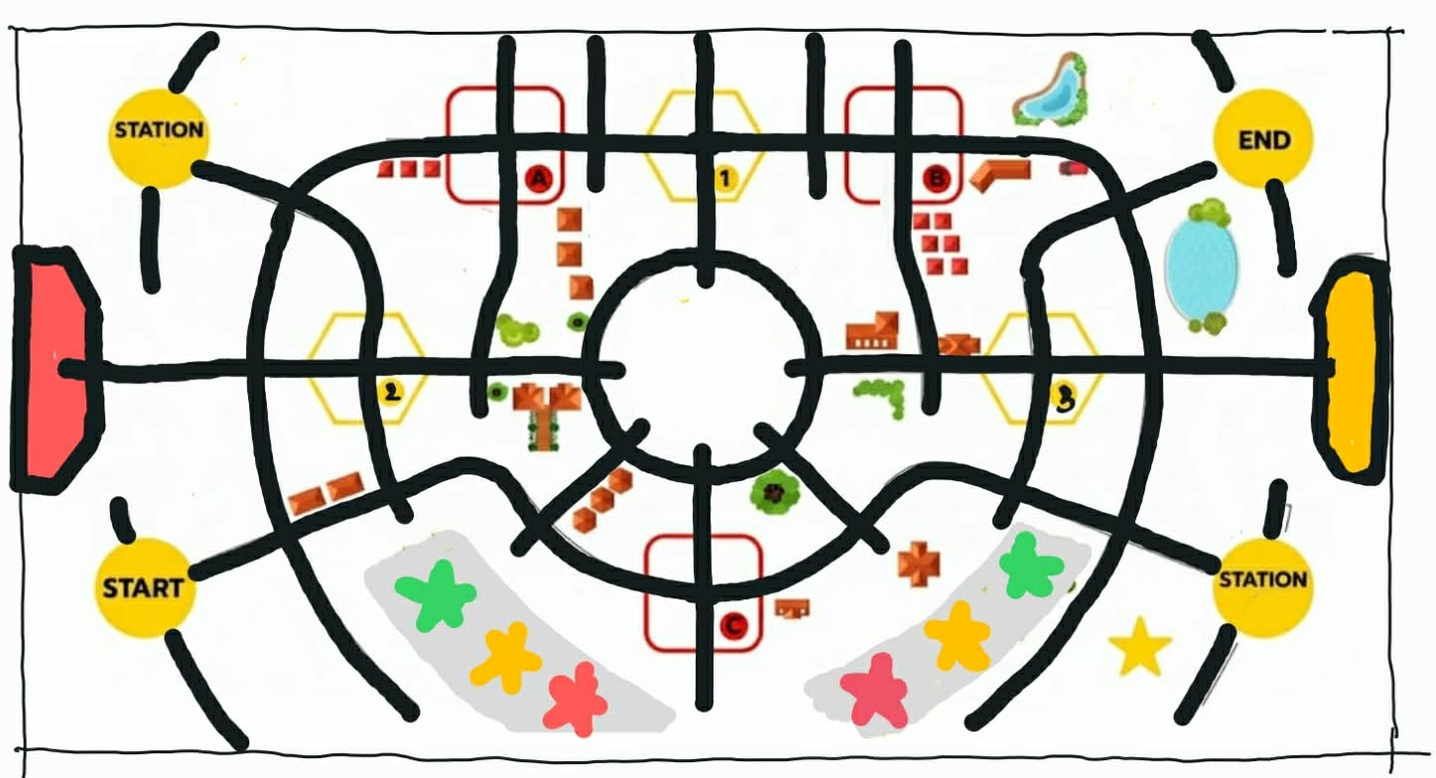
Examples of competition fields

3. Robot Tasks
3.1 Manually-controlled Robot (MN robot) : A robot for collecting energy bars
The MN robot is placed at STATION and begins operation from this point.
The MN robot's tasks are to pick up energy bars from the Energy Storage and distribute them according to city locations where energy is needed. Energy bar from green, yellow, and red stars must be placed at usage points A, B, and C, respectively. (The order of placement can be changed, but green must go to A, yellow to B, and red to C).

3.2 Automatic Robot (AUTO robot) : A robot for automatically transporting energy bars
The AUTO robot is placed at the START point and ends the operation at the END point.
The AUTO robot can start when the MN robot has successfully picked up an energy bar from the Energy Storage.
The AUTO robot's tasks are to pick up energy bars from point A and place them at charging point 1, from point B to charging point 2, and from point C to charging point 3, without any specific order. If an energy bar falls over at the charging point, a score is still awarded, and a team member is allowed to reposition it (but must request a permission from the field referee).

3.3 The MN robot resumes operation, when an energy bar is placed at a charging point. It moves the energy bar from that charging points 1, 2, or 3 to green, yellow, or red stars, respectively, and then return to the STATION.

4. Scores
4.1 Energy Bar Items
4.1.1 Successfully picking up an energy bar and exiting the area earns 5 points.
4.1.2 Placing an energy bar at points A, B, and C earns 5 points. If the bar falls over inside the area, a member can raise a hand to request a permission to pick it upright.
4.1.3 Collecting a used energy bar and placing at points 1, 2, or 3 to recharge the energy, using the AUTO robot, earns 10 points per point.
4.1.4 After recharging, moving an energy bar to the energy storage earns 8 points.

4.2 Robots
4.2.1 The MN robot successfully leaves the STATION will earn 10 points.
4.2.2 The AUTO robot successfully returns to the START point will earn 10 points.
4.2.3 The MN robot successfully returns to the STATION will earn 10 points.
4.2.4 The AUTO robot returning to the END point will earn 10 points.
4.3 Bonus Points: for First Blood 5 points will be awarded to the team that is the first to place the energy bars at positions A, B, or C.

5. Restrictions
5.1 Competitors are prohibited from touching or handling either of the two robots without the referee's permission. Any violation will result in a forced retirement.
5.2 Neither robot is allowed to leave the field. Any robot leaving the field will result in a forced retirement.

6. Retirement
6.1 Upon retirement, any action can be taken with the robot, but the robot must return to its starting point.
6.2 In the case of the AUTO robot, it must return to the START point and can either resume the task where it was left off before retirement or restart from the beginning. The energy bar that received scoring is allowed to be removed and placed at its original position, to avoid obstruction of the AUTO robot's path.
6.1.2 In the case of the MN robot, it must return to the STATION and can either resume the task where it was left off before retirement or restart from the beginning.

What is allowed and what is not allowed:
You must obtain permission from the referee every time; otherwise, you may lose points.

